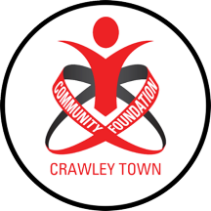

Complaints and Appeals Policy

Where the Foundation has clearly stated and communicated its philosophy, what it can offer to and what it expects from, staff, coaches, participants and volunteers, it should limit potential complaints.

Most complaints can be dealt with by referring individuals to club policies and procedures.

However, where there are complaints which cannot be satisfied via these routes alternative options can be considered:

STAFF
See Staff Handbook and Grievance Procedure.

CUSTOMERS
Crawley Town Community Foundation aims to provide customers with a high level of service.

However, if for any reason you’re not satisfied with the service that you have received from us, please contact a member of staff who will investigate and respond to your complaint.

If you are not happy with the response you receive and wish to make an escalated complaint, please follow our complaints procedure as detailed below.

We give our commitment that your concerns will be fully investigated.

How do I make a Formal Complaint?

Please send your complaint to
Crawley Town Community Foundation
Office Administration
Broadfield Stadium
Winfield Way
Crawley
RH11 9RX

Alternately email community@crawleytownfc.com

Next Steps
1.Once we have received the complaint, it will be acknowledged within 2-3 working days.
2. The complaint will be fully investigated and we aim to respond within 10 working days.
3. Should the situation require longer than 10 working days to be resolved, we will aim to respond in 10 working days to inform and say when a full response will be received.
4. The complaint will be kept on file to enable us to monitor the number and types of incidents

